Name: Bilal Abid Abbasi
ID:45961
Lab task 3

1. Employee Payroll System (Using Pointers)
#include <iostream>
using namespace std;
int main()
{
int n;
cout<<"Enter number of employees: ";
cin>>n;
double *salary;
salary = new double[n];
for(int i=0;i<n;i++)
{
cout<<"Enter salary of employee "<<i+1<<": ";
cin>>salary[i];
}
cout<<"\nEmployee Salaries\n";
for(int i=0;i<n;i++)
{
cout<<"Employee "<<i+1<<" Salary = "<<salary[i]<<endl;
}
delete[] salary;
return 0;
}
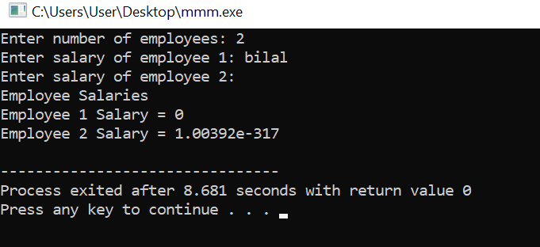

2. Dynamic Students Marks System
#include <iostream>
using namespace std;
int main()
{
int n;
cout<<"Enter number of students: ";
cin>>n;
int *marks;
marks = new int[n];
for(int i=0;i<n;i++)
{
cout<<"Enter marks of student "<<i+1<<": ";
cin>>marks[i];
}
cout<<"\nStudents Marks\n";
for(int i=0;i<n;i++)
{
cout<<"Student "<<i+1<<" Marks = "<<marks[i]<<endl;
}
delete[] marks;
return 0;
}
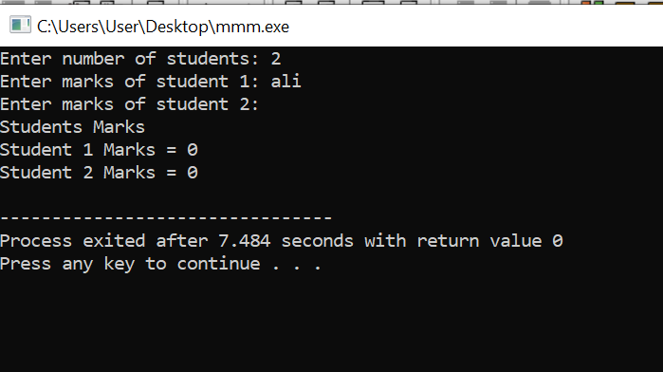

3. Dynamic Inventory Management System (Using Structure)
#include <iostream>
using namespace std;
struct Product
{
string name;
float price;
int quantity;
};
int main()
{
int n;
cout<<"Enter number of products: ";
cin>>n;
Product *p;
p = new Product[n];
for(int i=0;i<n;i++)
{
cout<<"\nEnter product name: ";
cin>>p[i].name;
cout<<"Enter price: ";
cin>>p[i].price;
cout<<"Enter quantity: ";
cin>>p[i].quantity;
}
cout<<"\nInventory Details\n";
for(int i=0;i<n;i++)
{
cout<<"Product: "<<p[i].name<<endl;
cout<<"Price: "<<p[i].price<<endl;
cout<<"Quantity: "<<p[i].quantity<<endl;
cout<<endl;
}
delete[] p;
return 0;
}
